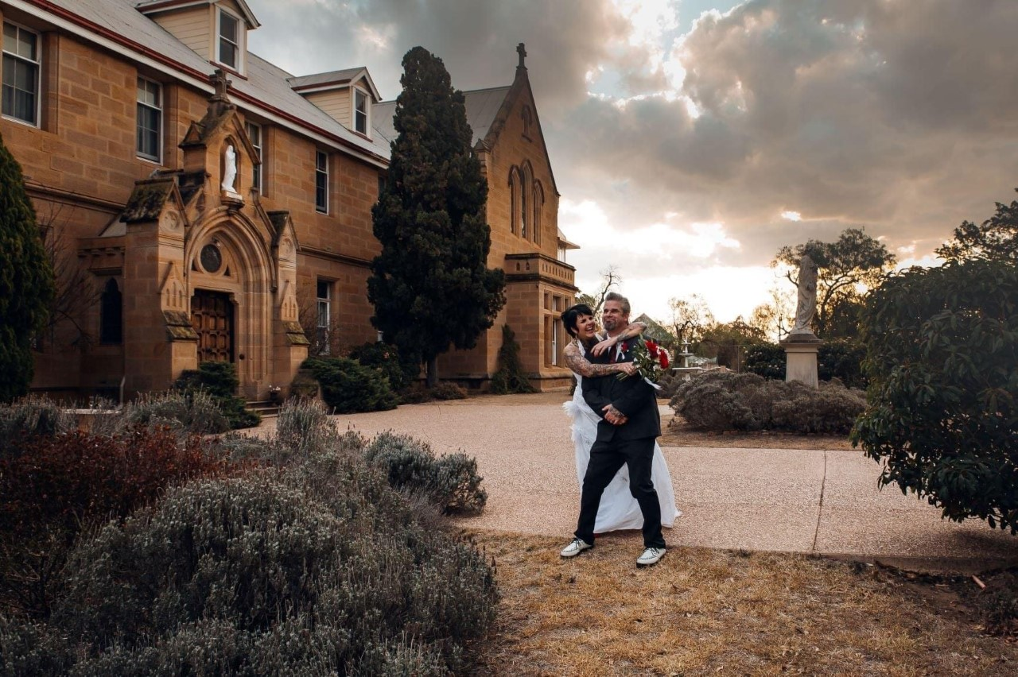
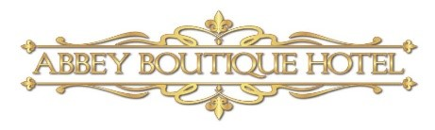
The Stress-Free
Fairytale Castle
Wedding Experience.

Index
- Packages:
- Mid-week Weddings.
- Just the 2 of you, Elopements.
- Romantic Intimate Wedding.
- Wedding Packages for 70+ guests.
- Extra add on’s.
- Dinner Menu.
- Beverage Menu.
- Accommodation.
- Frequently asked questions.
Standard inclusions in all wedding packs are:
- When included the ‘standard beverage package’ consists of 3 standard beers, red & white wine & soft drinks for outlined time. Sorry, no BYO food or drink.
- If speeches are during your beverage package time, a glass of sparking will be offered to your guests.
- Full table service for beverages by Abbey waitstaff.
- Skirted bridal & cake table, plus silver knife to use to cut your wedding cake (cake provided by you unless otherwise stated)
- Gift table or wishing well in reception room plus easel to display your table seating board (plan provided by you).
- Tables set with white linen napkins & tablecloth, glassware & Stanley Rogers cutlery.
- Self-serve tea & coffee available when desert is served.
- Includes reception room hire costs.
- Reception room available from 1 hour prior to wedding to add decorations.
- Use of the grounds for your photos (photographer not included unless stated)
- For night weddings there is a minimum amount of accommodation rooms that need to be booked – children can only stay if all rooms are booked by your group.
- Time lines in Winter can be bought forward ½ - 1 hour.
- Celebrant, photographer or other suppliers are NOT included in packages unless stated otherwise.
- Use of the grounds for your photos (photographer not included)
- At least rooms 3, 4 & 6 need to be booked. If you haven’t booked all the accommodation rooms, departure time for your guest is 9.30pm

PLEASE SEE TERMS & CONDITIONS FOR FULL OUTLINE.
*NOTE package pricing is not valid on public holidays

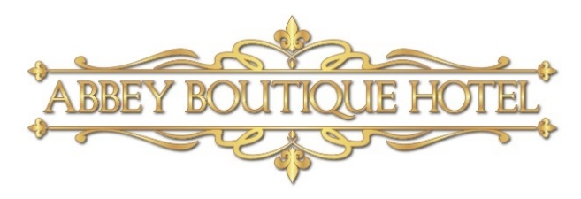

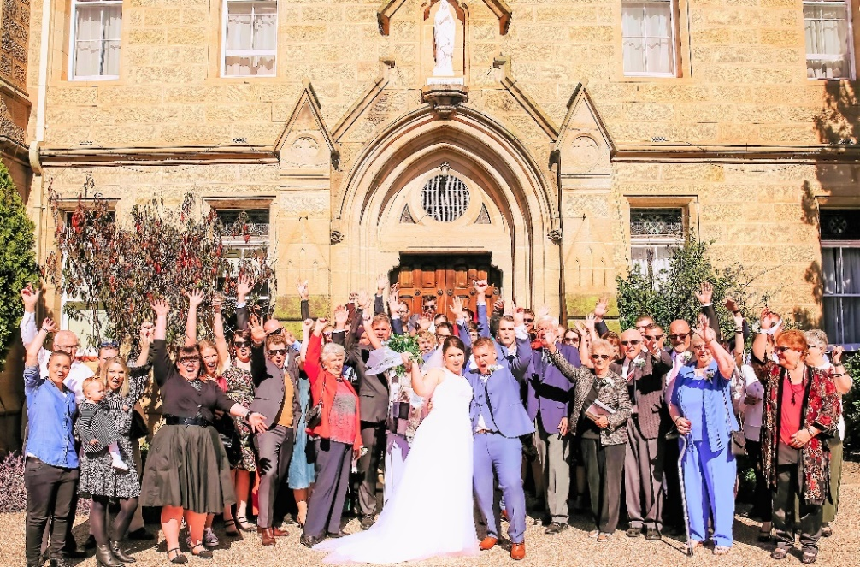

“
Mid-week Wedding Package.

INTRODUCTORY PRICE $4,150 FOR 2021 WEDDINGS DATES.

30 People with all the following inclusions $4,450.

Use of the Chapel for your ceremony.
Celebrant to conduct your wedding OR $650 towards accommodation.
Use of the grounds for your photos.
Photographer for an hour during your ceremony.
Seasonal bouquet and matching lapel pin.
Chefs Canapé’s.
Alternate serve mains.
Wedding cake, you have provided, served for dessert with self-serve tea & coffee.
West Wing Suite for the wedding couple to check into any time after 2pm.

*extra guests to total 40 - $70pp.

Proposed Time Line – to be discussed.
4pm Celebrant arrives in preparation of Ceremony.
4.15pm Guests arrive for Ceremony.
4.30pm Ceremony begins.
5pm Canapes are served whilst couple have photos.
5.45pm Guests are invited into the reception room.
6.00pm Couple make their entrance & cut the cake.
6.30pm alternate mains are served followed by speeches.
8pm Wedding cake served with self-serve tea and coffee available.
9.00pm Bar closes.
9.30pm Guests have left the Abbey. Additional time can be added if all accommodation rooms are booked.

We can custom make packages to suit most styles and budgets.

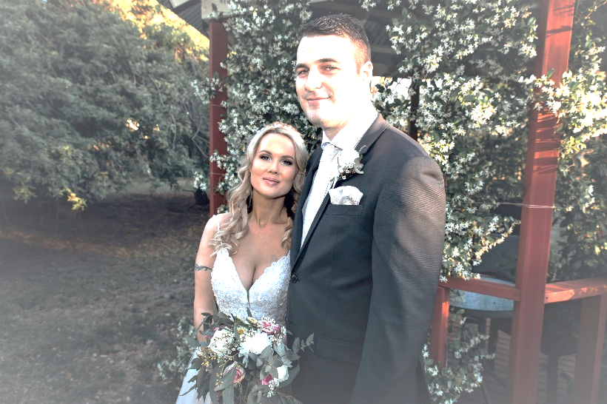

2021 “Just the 2 of you”
Elopement Options - Monday-Thursday 2021.

BYO Day Elopement.
From $600 on pop-up dates – 2 hours.
Use of the Chapel & grounds, 2 witnesses, glass of sparkling for toasting.

Elopement – overnight.
From $980.
Use of the Chapel & grounds, 2 witnesses, glass of sparkling for toasting.
2 course dinner in private dining room, accommodation in room 10 & breakfast.

Supplier Inclusive Elopement.
From $1,680 on pop-up dates – 2 hours
Use of the Chapel & grounds, 2 witnesses, glass of sparkling for toasting.
Celebrant & 1 hour of photography, bouquet of seasonal flowers & matching lapel pin.

Ultimate All-inclusive Elopement.
From $2,050 on pop-up dates.
Use of the Chapel & grounds, 2 witnesses, bottle of sparkling for toasting.
Celebrant & photographer, bouquet of seasonal flowers & matching lapel pin.
3 course dinner in private dining room, accommodation in a suite & breakfast.
Extra guests from $400/couple including dinner and accommodation.

We can custom make packages to suit most styles and budgets – including any extra guests.

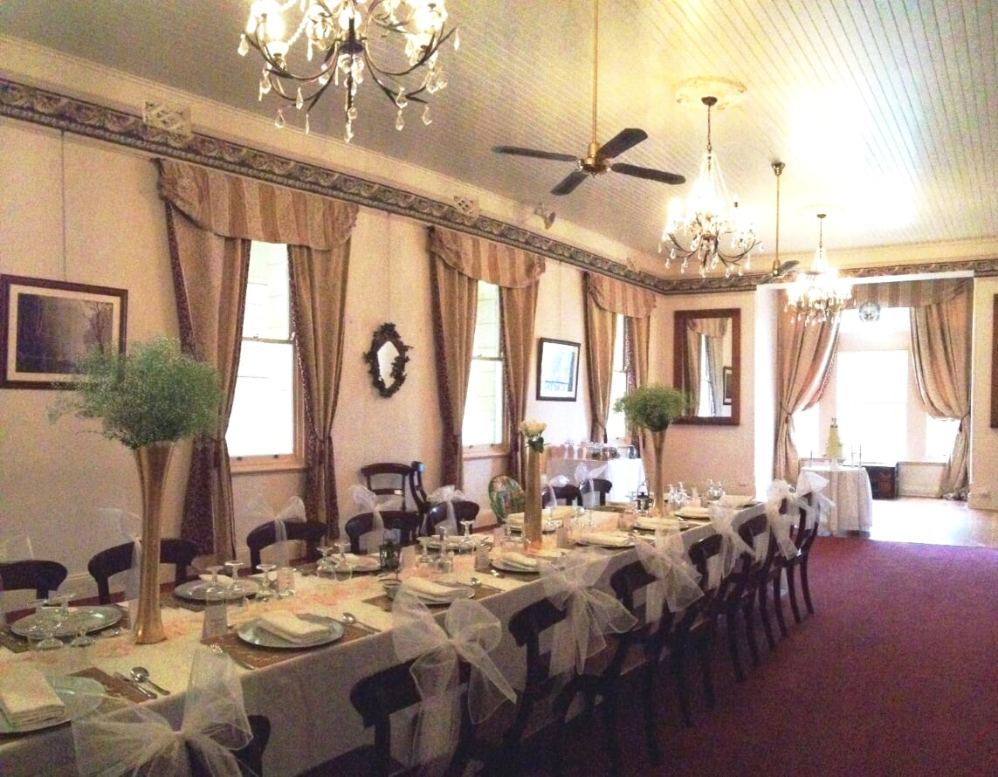

2021 Romantic Intimate Weddings 24+ people.
Intimate Mid-Week.
24+ people $200pp
Check in from 2pm.
Accommodation for all your guests.
Chapel for your Ceremony.
3 hours standard beverage package.
Canapes ½ hour.
Alternate serve mains.
Self-serve tea & coffee.
Breakfast for all your guests

Intimate Ultimate Wedding.
Mid-week $245pp. 24+ people
Friday $270pp. Saturday $320pp. 30+ people.
Check in from 2pm
Accommodation for all your guests.
Welcome to the ceremony beverage.
Chapel for your Ceremony.
5 hour standard beverage package.
Canapes 1 hour.
Alternate serve mains.
Self-serve tea & coffee.
Breakfast for all your guests.

We can custom make packages to suit most styles and budgets.

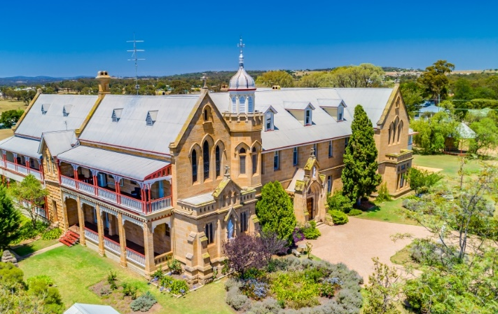

2021 Wedding Packages for 70+ people.

Classic Castle Wedding Reception
$92 Friday. $105 Saturday - with 80 guests.
Standard Beverage Package from 5-8pm.
Chefs Canapes for ½ hour.
Alternate serve mains.
Wedding cake, you have provided, served for dessert with self-serve tea & coffee.

Gold Wedding Package.
$17,900 Friday or $18,900 Saturday night for up to 70 Guests.
Use of the Chapel for your Ceremony.
Accommodation for up to 28 guests in 14 rooms with breakfast for those who stayed over. Chefs Canapes for 1hour.
Standard beverage package for 5 hours.
Alternate serve mains & your wedding cake for dessert.
Chocolate and mints with self-serve tea & coffee.

Platinum Wedding Package – all inclusive.
$26,900 Friday. $29,500 Saturday - up to 70 guests.
Everything in Gold Wedding Package,
PLUS
Extra nights accommodation the day before your wedding for same guest.
Use of the beauty room for bridal party to use for hair and makeup with light lunch.
Celebrant to conduct your Ceremony.
Professional Photographer for 4 hours.
DJ for 5 hours.
Guests offered a welcome beverage on arrival.
6 hour prestige beverage package.
Table Decorations.
Lolly Buffet.
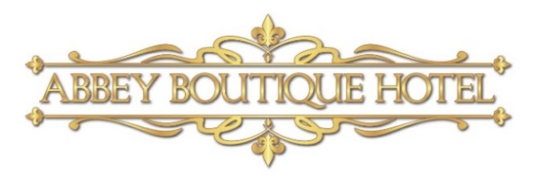
Port & Cheese for your guests.

Some extras you might like to add more “wow” to your wedding day.

The “I Do Bar”.
The new “I Do Bar” is a novel end of the night surprise for your guests. It is set up at 9pm outside the Long Room with spirits served by Abbey Team Members. You may opt for a tab to be paid at the end of the night or pre-paid beverage package for added value.
Prepay $300 & receive $350 of spirits (need a min of 20 guests) Prepay $500 & receive $600 of spirits (need a min of 30 guests) Prepay $600 & receive $750 of spirits (need a min of 45 guests)
OR
$10/ spirit are added to your tab to be paid at the end of the night.

Lolly Buffet.
The lolly buffet is set up with jars of assorted sweets for your guests to fill a provided lolly bag after dessert as a take home or eat at your wedding treat.
$11/person up to 30 people. Then $7.50/person for extra guests

Cheese Station or Plated.
About an hour after dessert, we can have a cheese station (if under 80 guests) or cheese platters for your guests to graze from $11pp.
Add a tray of Sherry or Port for $3.50 per glass

After Dessert Bar.
About an hour after your wedding cake has been served for dessert, we put together a ‘mini’ dessert bar with small, sweet items & chocolate to nibble on whilst having self-serve tea or coffee.

The Soak Course!
Something trending at the Abbey is the ‘soak course’. Served about 1 ½ hours after dessert are platters of finger foods so tummy’s have some substance in them whilst guests are still enjoying a couple of beverages. It aims to help ‘soak up’ alcohol.
Plates of pies, sausage rolls with tomato sauce, small bread rolls with ham & mustard etc. From $10pp.

Horse & Carriage.
If you are having your ceremony off-site, a horse & carriage to your church & back is a wonderful, romantic addition to cement some memories, plus the photo opportunities that you can keep forever!
Music during Canapé’s.
A string quartet can be arranged to play during your ceremony or whilst guests are enjoying canapés from approx $300/hour.
Bag pipes can also be arranged to pipe you down the aisle or when you arrive after your ceremony off-site from $200 or a full band from approx. $480.- POA
A pianist can be arranged to play as your guests are in the chapel, as you walk down the aisle & as you leave the chapel- POA

Wedding Planner/Stylist.
Variety of different table decorations available POA. Peta is a ‘one stop’ stylist who can co-ordinate your decorations, flowers and photographer
Peta from Wedding & Events. 0414 683 951 Facebook “Weddings & Events Warwick”

Cake.
There are some great local cake makers in town: Sweet Petals Cake by Debbie Hughes 0429 177 595
Story Book Cakes by Karyn & Mark 0478 125 620

DJ & Master of Ceremony.
A professional wedding DJ can be added to your package outline to ensure the best music is played for your guests at the appropriate time. From $700 for 5 hours. DJ’s can also perform master of ceremony duties. Contact Helen from Top Beat (07) 4681 0681 POA
Florist.
Blooms of Warwick are a reliable local florist who will deliver on the day of your wedding. Blooms of Warwick 0414 683 951

The Abbey caters for:
- Elopement & Pop-up packages from $600
- Intimate Packages for 20-30 people with ceremony, accommodation, canapé’s, beverages dinner and breakfast the next morning from $200
- Plus packages for up to 120 people to suit most styles and budgets
From $1500 POA

Entrée
Homemade Abbey Pumpkin Soup. (V, DF, GF)
Crumbed Lamb Cutlets on a Potato Puree with a hint of mint.
Prawn Cocktail with a Ginger & Lime salad.
Stuffed Field Mushrooms. (V, GF, DF available)

Main Course
All main course’s served with fresh seasonal vegetables.
Classic Roast- Alternate style mains with a choice of/Roast Beef, Horseradish & Yorkshire pudding/Leg of Lamb with mint sauce/ Loin of Pork with crackling and apple sauce. (DF,GF available)
Eye Fillet on a Creamy Potato Mash with a Shiraz Jus. (GF, DF available)
Grilled Salmon on a Brown Rice. (GF)
Seared & Roasted Duck Breast on a Cauliflower Puree. (GF, DF available)
Skinless Chicken Breast filled with Camembert, Bacon, Pine nuts, Spinach & a potato stack topped with a Galliano sauce.
Vegetarian Parcel with Tomato Chutney (V, DV available)

Dessert
Wedding Cake, provided by you, served with Chef’s Garnish.
Individual Mini Pavlova with a Fresh Fruit Salad & Cream. (GF available)
Profiteroles with Chocolate Ganache, Strawberry Salad with Gold Dust.
Chocolate Pudding, Chocolate Soil & Cream.
Sticky Date Pudding, Chocolate Soil & Cream

Frequently Asked Questions
Q. Where at the Abbey grounds can we get married? A. You have the option of getting married in the Chapel, out under one of our gazebos or on the front steps with the house as your backdrop.
Q. Can I bring my own catering and alcohol? A. As we are a fully licenced establishment BYO is not permitted. Your own alcohol may be consumed in your accommodation room, and catering is all done by the Abbey team (excluding wedding cake).
Q. Can I take my guests to my accommodation room? A. Only guests booked into the accommodation to stay the night at the Abbey are permitted to go accommodation rooms.
Q. Can I make changes to the packages? A. We have never had two weddings the same, that is why all our wedding packages are fully customizable to suit your needs & budget.
Q. Can I come to view the Abbey? A. Absolutely it is encouraged, please contact us via phone or email to book in an appointment time.
Q. Do you have off season deals or special offers? A. Yes! See our website for all our deals and savings.
Q. Can we stay at the abbey? A. Accommodation starts from $150-$420, for up to 2 adults per room. The rooms vary in sizes, some rooms being an ensuite, others with a private bathroom down the hall. Please see our website for pictures and room descriptions.
Q. Can children stay at the Abbey? A. Children are welcome to attend functions, but unless you have booked out the all the accommodation (every room), they are not permitted to stay the night as we are an adult only accommodation.

